- MICHAEL GRAVES
(born July 9, 1934)
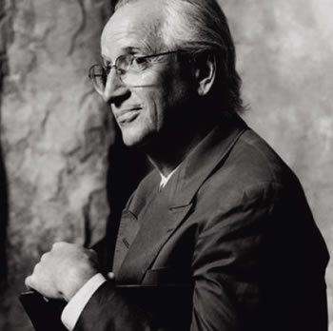
Michael Graves is an American architect. Identified as one of The New York Five, Graves has become a household name with his designs for domestic products sold at Target stores in the United States.
Graves was born in Indianapolis, Indiana. He attended Broad Ripple High School, receiving his diploma in 1952. He earned a bachelor's degree from the University of Cincinnati where he also became a member of the Sigma Chi fraternity, and a master's degree from Harvard University.
An architect in public practice in Princeton, New Jersey, since 1964, Graves is also the Robert Schirmer Professor of Architecture, Emeritus at Princeton University. He directs the firm Michael Graves & Associates, which has offices in Princeton and in New York City. In addition to his popular line of household items, Graves and his firm have earned critical acclaim for a wide variety of commercial and residential buildings and interior design, although some occupants of the buildings object to the confined views caused by signature features such as small or circular windows and squat columns. Graves was elected a Fellow of the American Institute of Architects (AIA) in 1979. In 1999 Graves was awarded the National Medal of Arts, in 2001 the AIA Gold Medal, in 2010 the AIA Topaz Medal, and in 2012 the Driehaus Prize for Classical Architecture. He is also a Senior Fellow of the Design Futures Council.
In 2003, an infection of unknown origin (possibly bacterial meningitis) left Graves paralyzed from the waist down. He is still active in his practice, which is currently involved in a number of projects; including an addition to the Detroit Institute of Arts, and a large Integrated Resort, Resorts World Sentosa in Singapore.

M.Graves
  Humana Building in Louisville, Kentucky | 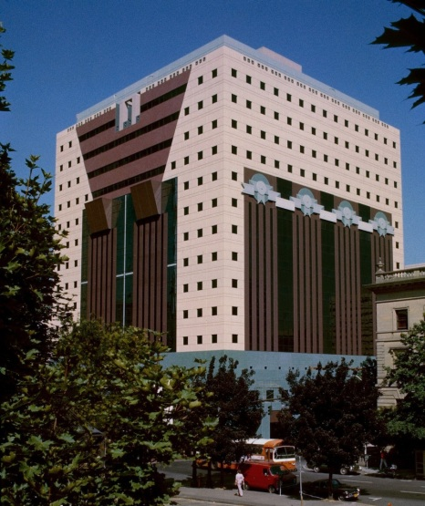  The Portland Building in Oregon_1982 | 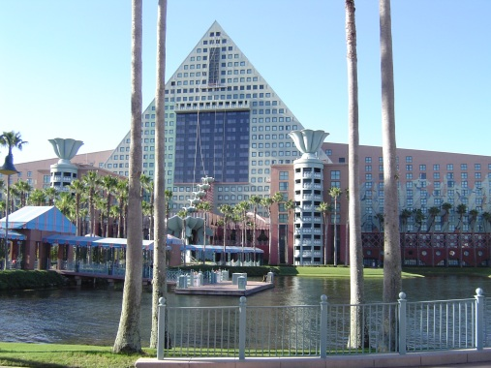  The Walt Disney World Dolphin Resort in Orlando, Florida
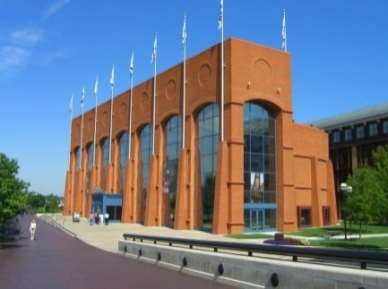  NCAA Hall of Champions in Indianapolis, Indiana. | 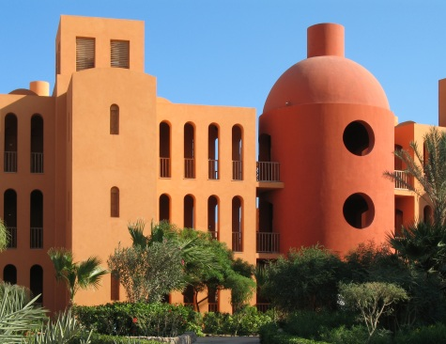  Steigenberger Hotel in El Gouna, Egypt, in association with Ahmed Hamdy | 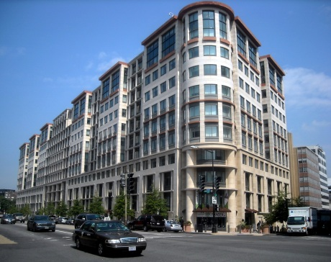  The International Finance Corporation Building in Washington, D.C.

- ROBERT ARTHUR MORTON STERN
(born May 23, 1939)
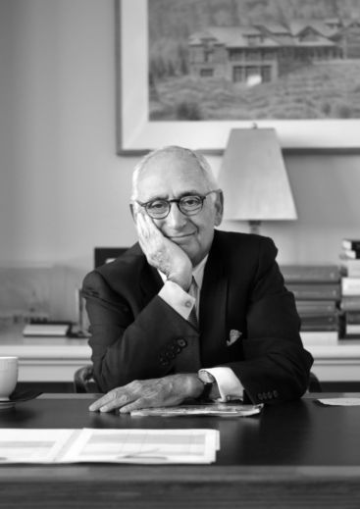
Robert A.M. Stern is a practicing American architect, teacher, and writer. He is a Fellow of the American Institute of Architects, and received the AIA New York Chapter's Medal of Honor in 1984 and the Chapter's President's Award in 2001. Mr. Stern is the 2011 Driehaus Prize laureate and in 2008 received the tenth Vincent Scully Prize from the National Building Museum. In 2007, he received both the Athena Award from the Congress for the New Urbanism and the Board of Directors' Honor from the Institute of Classical Architecture and Classical America. As founder and Senior Partner of Robert A.M. Stern Architects, he personally directs the design of each of the firm's projects.
Mr. Stern is Dean of the Yale School of Architecture. He was previously Professor of Architecture and Director of the Historic Preservation Program at the Graduate School of Architecture, Planning, and Preservation at Columbia University. Mr. Stern served from 1984 to 1988 as the first director of Columbia's Temple Hoyne Buell Center for the Study of American Architecture. He has lectured extensively in the United States and abroad on both historical and contemporary topics in architecture. He is the author of several books, including New Directions in American Architecture (Braziller, 1969; revised edition, 1977); George Howe: Toward a Modern American Architecture (Yale University Press, 1975); Modern Classicism (London: Thames & Hudson; New York: Rizzoli, 1988); The Philip Johnson Tapes: Interviews by Robert A.M. Stern (Monacelli, 2008); Architecture on the Edge of Postmodernism: Collected Essays 1964–1988 (Yale University Press, 2009); and Tradition and Invention in Architecture: Conversations and Essays (Yale University Press, 2011). Mr. Stern's profound interest in the development of New York City's architecture and urbanism can be seen in his books, New York 1900 (Rizzoli, 1983) coauthored with John Massengale and Gregory Gilmartin; New York 1930 (Rizzoli, 1987) coauthored with Thomas Mellins and Gregory Gilmartin, which was nominated for a National Book Award, an unusual distinction for a book about architecture; New York 1960 (Monacelli, 1995); New York 1880 (Monacelli, 1999) coauthored with Thomas Mellins and David Fishman; and New York 2000 (Monacelli, 2006), coauthored with David Fishman and Jacob Tilove.
Fifteen books on Mr. Stern's work have been published: Robert Stern (London: Academy Editions, 1981); Robert A.M. Stern Buildings and Projects 1965-1980 (New York: Rizzoli, 1981); Robert A.M. Stern: Buildings and Projects 1981-1985 (New York: Rizzoli, 1986); Robert A.M. Stern: Modernità e Tradizione (Rome: Edizioni Kappa, 1990); The American Houses of Robert A.M. Stern (New York: Rizzoli, 1991); Architectural Monographs no. 17, Robert A.M. Stern: Selected Works (London: Academy Editions, New York: St. Martins Press, 1991); Robert A.M. Stern: Buildings and Projects 1987-1992 (New York: Rizzoli, 1992); Robert A.M. Stern: Buildings (New York: Monacelli, 1996); Robert A.M. Stern: Houses (New York: Monacelli, 1997); Robert A.M. Stern: Buildings and Projects 1993-1998 (New York: Monacelli, 1998); Robert A.M. Stern: Buildings and Projects 1999-2003 (New York: Monacelli, 2003); Robert A.M. Stern: Houses and Gardens (New York: Monacelli, 2005); Robert A.M. Stern: Buildings and Towns (New York: Monacelli, 2007); Robert A.M. Stern: Buildings and Projects 2004-2009 (New York: Monacelli, 2009); and Robert A.M. Stern: On Campus (New York: Monacelli, 2010).
Mr. Stern's work has been exhibited at numerous galleries and universities and is in the permanent collections of the Museum of Modern Art, the Metropolitan Museum of Art, the Deutsches Architekturmuseum, Centre Pompidou, the Denver Museum of Art, and the Art Institute of Chicago. In 1976, 1980, and 1996, he was among the architects selected to represent the United States at the Venice Biennale, and he served as Chair of the International Jury in 2012. In 1986 Mr. Stern hosted "Pride of Place: Building the American Dream," an eight-part, eight-hour documentary television series aired on the Public Broadcasting System. Mr. Stern served on the Board of Directors of The Walt Disney Company from 1992 to 2003. Mr. Stern is a graduate of Columbia University (B.A., 1960) and Yale University (M. Architecture, 1965).

Robert A.M. Stern

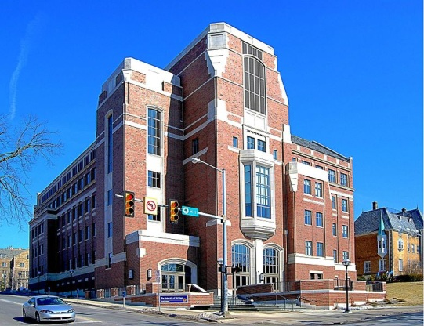Gerald R. Ford School of Public Policy | 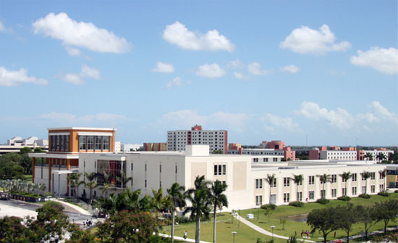  Rafael Diaz-Balart Hall, home of the FIU College of Law in Miami, Florida. |   Norman Rockwell Museum.
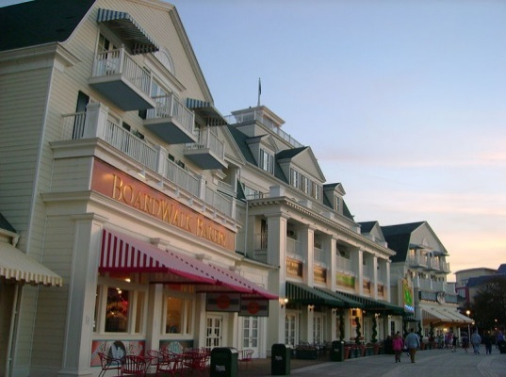  Disney's BoardWalk Resort  Hotel and entertainment complex at the Walt Disney World Resort | 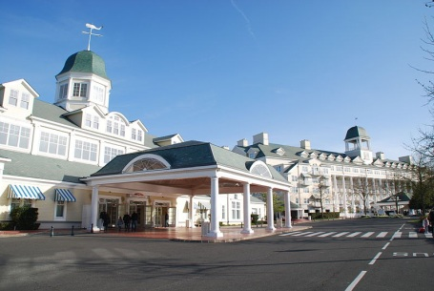  Disney's Newport Bay Club | 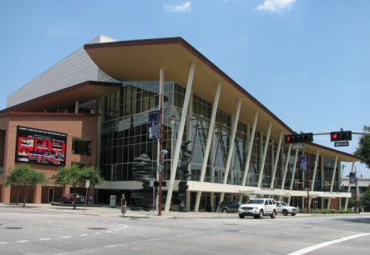  Hobby Center for the Performing Arts

